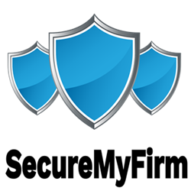 SecureMyFirm Inc.

3336 Glenhurst Ave.

Minneapolis, MN 55416

Tel: 952-922-1120

Email: info@securemyfirm.com

May 15, 2025

<<ClientNameFull>><<OptionClientTitle>>

<<ClientTitle>><<OptionClientTitle/>>

<<ClientOrg>>

<<ClientAddress>><<OptionAddress2>>

<<ClientAddress2>><<OptionAddress2/>>

<<ClientCity>>, <<ClientState>> <<ClientZipcode>>

Re: <<MatterDescription>><<OptionOurFileNo>>

Our File No.: <<OurFileNo>><<OptionOurFileNo/>>

Dear <<Choice1First>><<ClientFirst>><<Choice1First/>><<Choice2MrMsLast>><<ClientMrMs>> <<ClientLast>><<Choice2MrMsLast/>>:

I hope this letter finds you well. I am most grateful for your continued support and partnership with <<SenderOrg>>. Working with you on this matter is a privilege and your able participation plays a pivotal role in our success together.

We truly appreciate the trust you place in us and are grateful for the opportunity to work with <<ClientOrg>>. Clients such as you make our work fulfilling and effective.

Looking forward, we are enthusiastic about our ongoing and future collaborations. We are committed to continuing to provide you with the highest level of service and support.

Thank you once again for your business and trust. Please do not hesitate to let me know if you have any questions or anything you would like us to consider.

With sincere thanks,

Sincerely,

<<SenderNameFull>><<OptionSenderTitle>>

<<SenderTitle>><<OptionSenderTitle/>>